The value of machine learning in detection and assessment of liver trauma using contrast enhanced CT scans
Abstract
Background: Over the last few years, there has been increasing interest in the use of artificial intelligence to assist with abnormality detection on medical images. Aim of this study was to investigate the performance of Artificial Intelligence on the detection of trauma in liver with High Resolution Multi slice Computed Tomography. Methods: this prospective study was done on 65 cases, who underwent automatic detection of liver trauma based on computer-aided detection systems, focuses on the artificial intelligence technology applied in liver multislice CT scans Using High Resolution Multi slice Computed Tomography ( 16/64/128 detector ) for liver examination for abnormality detected by artificial intelligence technology. Results: a mean age of 20 years with a standard deviation of 15 years. The diagnostic performance of artificial intelligence for detecting liver lesions was analyzed. The models demonstrated good agreement for detecting hepatic lesions. Conclusion: The proposed algorithms can accurately segment the liver and the regions affected by trauma. This pipeline demonstrates an accurate performance in estimating the percentage of liver parenchyma that is affected by trauma. Such a system can aid critical care medical personnel by providing a reproducible quantitative assessment of liver trauma as an alternative to the sometimes- subjective AAST grading system that is used currently Keywords: Artificial Intelligence; post contrast computed tomography scan, liver injury .
Abbreviations
- AI: artificial intelligence.
- AAST: American Association for the Surgery of Trauma
- CT: computed tomography
- CECT : contrast enhanced computed tomography
- DL: deep learning.
- ML: machine learning.

Introduction
Trauma is the primary cause of mortality for individuals younger than 46 years old (1). Approximately 5% of all trauma admissions are attributed to liver trauma. Due to its anterior location, large size, and fragile parenchyma, the liver is the most frequently injured abdominal organ involved in blunt abdominal trauma (2). Early detection and severity assessment of liver trauma with adequate treatment may result in significant reduction of morbidity and mortality (3) .
Contrast-enhanced computed tomography (CT) is considered the gold standard technique in evaluating liver trauma and monitoring its progression over time (4).
CT imaging is used to grade liver injuries based on the American Association for the Surgery of Trauma (AAST) liver injury scale is the primary tool currently in use to assess the extent of the liver trauma and guide management. (5)
(Figure 1).
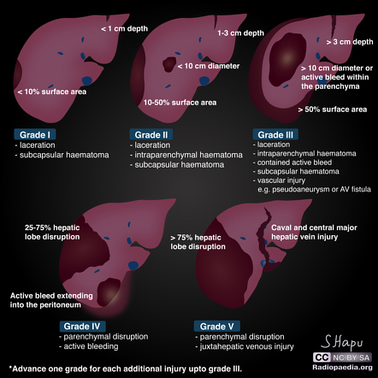
Figure 1. The AAST (American Association for the Surgery of Trauma) liver injury scale, revised in 2018, is the most widely used liver injury grading system
AI or machine intelligence is an area of computer science whereby machines are programmed with the ability to perform intelligent tasks that are usually undertaken by humans (6).
A common definition of AI is that it is a technology that enables machines to imitate various complex human skills. This, however, does not give is much to go on. In fact, it does no more than render the term ‘artificial intelligence’ in different words. As long as those ‘complex human skills’ are not specified, it remains unclear exactly what AI is. The same applies to the definition of AI as the performance by computers of complex tasks in complex environments.( 7) (figure 2)
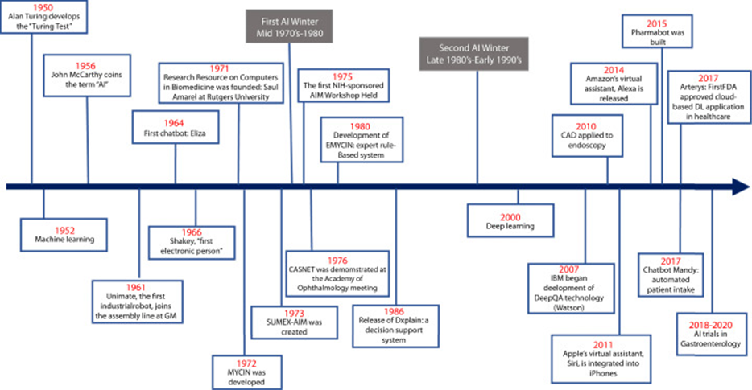
Figure 2. Timeline of the development and use of artificial intelligence in medicine. AI, Artificial intelligence; DL, deep learning;
(AI) encompasses several subfields, similar to specialized areas in medicine ,including machine learning (ML), deep learning (DL), and computer vision (8).
AI's role in CT imaging focuses on image analysis and pattern recognition. AI systems can be trained on large datasets of CT images to identify patterns that are indicative of liver trauma. These systems can highlight areas of concern, such as lacerations, contusions, or hematomas, which might be missed by the human eye due to the complexity of the images or the subtlety of the trauma (9)
A study was done to develop a fully automated image processing and deep learning framework that provides clinicians with quantitative assessment of hepatic trauma. This framework can act as a triage tool by rapidly assessing liver injury and its severity. To this end, both the whole liver parenchyma and liver trauma regions are automatically segmented in abdominopelvic CT scans. Accordingly, the percentage of liver parenchyma that is affected by trauma will be computed. (10).( figure 3)

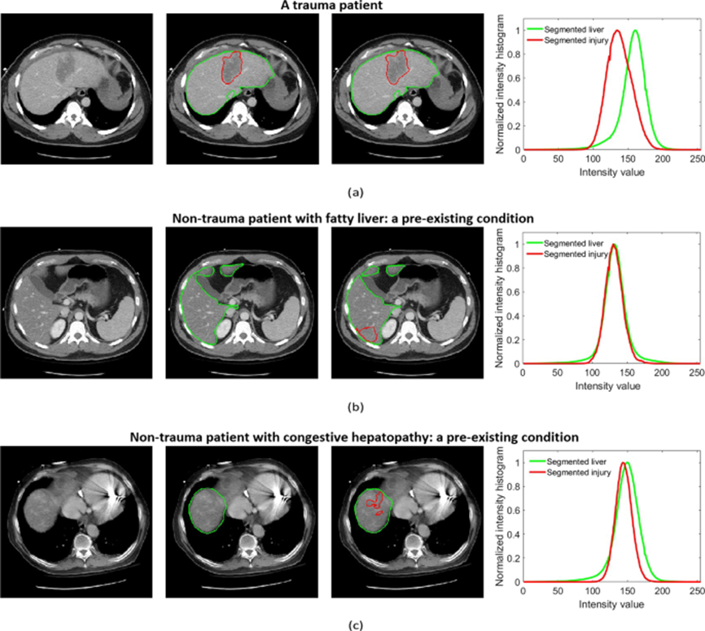
Figure 3: liver trauma and organ segmentation results as well as ground truth annotations in patients with trauma or pre-existing conditions. (a) Axial contrast-enhanced CT image shows an intraparenchymal hematoma in the left liver lobe. (b) Axial contrast-enhanced CT image shows diffuse low attenuation of the right liver lobe fat deposition.. (c) Axial contrast-enhanced CT image shows heterogeneous enhancement of the right liver dome due to congestive hepatopathy, and the third column corresponds to the automated segmentation results before post-processing. In both ground truth annotations and segmentation results. The fourth column compares the pixel intensity distribution inside the segmented liver and the segmented trauma region.

1.Rhee P, Joseph B, Pandit V, Aziz H, Vercruysse G, Kulvatunyou N, Friese RS. Increasing trauma deaths in the United States. Ann Surg. 2014;260(1):13–21.
2.Ahmed N, Vernick JJ. Management of liver trauma in adults. J Emerg Trauma Shock. 2011;4(1):114
3.Barrie J, Jamdar S, Iniguez MF, Bouamra O, Jenks T, Lecky F, O’Reilly DA. Improved outcomes for hepatic trauma in England and Wales over a decade of trauma and hepatobiliary surgery centralisation. Eur J Trauma Emerg Surg. 2018;44(1):63–70.
4.Farzaneh, N. et al. (2022) “A deep learning framework for automated detection and quantitative assessment of liver trauma,” BMC Medical Imaging, 22(1)
5.Nguyen, Q. T., Patel, R., & Liu, Y. (2021). CT Grading and Management of Severe (Grade V) Liver Injuries. American Journal of Roentgenology, 217(5), 456-463.
6.K.C.H. Tsang, H. Pinnock, A.M. Wilson, S.A. Shah
Application of machine learning to support self-management of asthma with mHealth
The 42nd Annual International Conference of the IEEE Engineering
in Medicine & Biology Society (2020),
7. Sheikh, H., Prins, C., Schrijvers, E. (2023). Artificial Intelligence: Definition and Background. In: Mission AI. Research for Policy. Springer, Cham.
8.Vivek Kaul, Sarah Enslin, Seth A. Gross. History of artificial intelligence in medicine. Gastrointestinal Endoscopy, 2020, 92(4): 807-812,
9.Litjens, G., et al. (2017). A survey on deep learning in medical image analysis. Medical Image Analysis, 42, 60-88.
10.Huang, S., Zhou, Z., Qian, X. et al. Automated quantitative assessment of pediatric blunt hepatic trauma by deep learning-based CT volumetry. Eur J Med Res 27, 305 (2022). https://doi.org/10.1186/s40001-022-00943-1

